**Molecular Dynamics Simulations of a Polymer Chain**

Yufei Chen

1. **Introduction**

Polymer folding is a phenomenon observed in both natural and synthetic polymers. It plays a crucial role in determining the mechanical, chemical, and biological properties of these materials. For instance, in biological systems, the folding of proteins (e.g., beta sheets) is essential for their proper functionality. In synthetic polymers, folding significantly affects the mechanical and thermal properties of many commercial polymers, which are often semi-crystalline, consisting of alternating amorphous and crystalline layers with characteristic thicknesses. Thus, understanding polymer folding behavior provides deeper insights into essential biological processes and drives innovations in the development of advanced materials.

In this project, we simulated the molecular dynamics of a polymer chain under various parameters to explore the transition between folding and unfolding. The purpose of the simulation is to uncover the relationship between polymer folding and the chosen parameters and to guide the design of materials that remain stable and resist folding at any temperature, specifically for space applications.

1. **Methods**
   1. **Simulation Model**

In this simulation, a bead-spring model was employed to represent the polymer chain. Figure 1 illustrates the bead-spring model of a polymer coil, where the beads correspond to individual monomers or repeating units of the polymer chain, and the springs symbolize the covalent bonds connecting adjacent units.

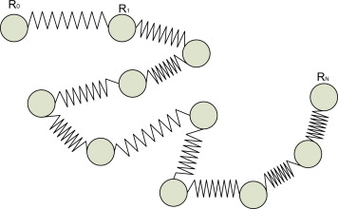

**Figure 1.** Bead-spring model.[1]

During the simulation, a harmonic potential was applied between adjacent beads to model the bonded interactions between the repeating units of the polymer chain. In addition, Lennard-Jones potential was employed to representl the non-bonded interactions between the beads that separated by one or more spacers, accounting for both excluded volume effect and attractive interactions.

Periodic boundary conditions were also implemented to simulate the bulk behavior of the polymer chain and eliminate the edge effect by creating an effectively infinite system. During the simulation, when a particle leaves one side of the primary simulation box, it re-enters the box from the opposite side.

**2.2 Algorithm**

In this project, we used molecular dynamics to simulate the folding and unfolding of a polymer chain. Molecular dynamics simulate the motion of particles over time by solving Newton’s equation of motion, which includes the following key steps:

1. **Initialize positions and velocities of particles.** In this simulation, the initial positions of particles are generated randomly, and the initial velocities are sampled from a Maxwell-Boltzmann distribution corresponding to the target temperature.
2. **Apply periodic boundary conditions.** During the simulation, when a particle leaves the simulation box, it will re-enter the box from the opposite side.
3. **Compute forces.** Fores acting on the particles are derived form the system’s potential energy, which includes harmonic bond potential, attractive and repulsive Lennard-Jones potential.
4. **Velocity Verlet integration.** In the simulation, particle positions, velocities and forces are updated continuously using velocity Verlet integration.
5. **Velocity rescaling thermostat.** This algorithm was used in the simulation to ensure the system reaches and maintains constant temperature by rescaling the velocities of particles periodically to match the target temperature.
   1. **Simulation parameters**

The parameters used in the simulation include the following:

1. **Polymer length:** 20 beads were used in most of the simulations. For those simulations studying the influence of chain length on polymer folding, 5, 10, 20, 40 and 100 beads were used respectively.
2. **Temperature range**: the simulation temperature ranges from 0.1 to 1.0.
3. **Interaction strength:** parameters for simulating the interaction strength include spring constant (*k*, ranging from 0 to 5), and depth of the repulsive potential (εrepulsive, ranging from 0 to 5). The depth of the attractive potential (εrepulsive = 0.5) and Lennard-Jones potential parameter (σ = 1.0) remain constant during the simulation.
   1. **The calculated properties**

During the simulations, radius of gyration (Rg), end-to-end distance (Ree) and potential energy were calculated to identify the folding and unfolding of the polymer.

**Radius of gyration**: the root mean square of the polymer’s parts from its center of mass, quantifying the spatial extent of the polymer.

**End-to-end distance**: the linear distance between two terminal repeating units of the polymer.

1. **Results**

**3.1 The transition of folding and unfolding**

When a spring constant of 1.0 (*k* = 1.0) and a depth of repulsive potential of 1.0 (εrepulsive = 1.0) were applied in the simulation, the transition of the polymer chain from a folded to an unfolded state was observed as the temperature increased from 0.1 K to 1.0 K. As shown in Figure 2, when the temperature was below 0.6 K, the polymer chain’s radius of gyration remained relatively small and constant. However, a sharp increasement of the radius of gyration occured when temperature reaches 0.7 K, indicating the occurrence of phase transition from a folded state to an unfolded state.

**Figure 2.** Radius of gyration vs temperature (*k* =1.00, epsilon repulsive = 1.00)

**Figure 3.** End-to end distance vs temperature (*k* =1.00, epsilon repulsive = 1.00)

**Figure 4.** Potential energy vs temperature (*k* =1.00, epsilon repulsive = 1.00)

Besides, the end-to-end distance of the polymer chain exhibited a similar transition as the temperature increased (Figure 3). The potential energy of the polymer chain rose to a high level before the transition temperature and became relatively stable afterwards (Figure 4).

Additionally, a comparison of the final configurations of the polymer chain further highlights the transition from the folded to the unfolded state. At 0.1 K, the polymer chain configuration (Figure 5) was more compact, occupying minimal space within the simulation box. In contrast, at 1.0 K, the configuration (Figure 6) was more extended, occupying a significantly larger portion of the simulation box

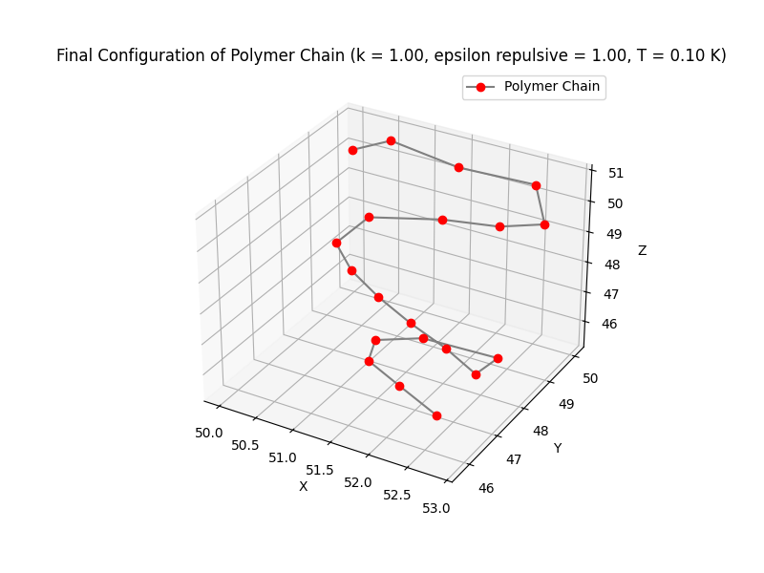

**Figure 5.** Final configuration of polymer chain (*k* = 1.00, epsilon repulsive = 1.00, T = 0.10 K)

**Figure 6.** Final configuration of polymer chain (*k* = 1.00, epsilon repulsive = 1.00, T = 1.00 K)

* 1. **The influence of spring constant *k***

The spring constant *k* represents the bonded interaction between the adjacent repeating units of the polymer chain. A larger spring constant *k* results in a greater force between the repeating units, making the polymer chain more rigid compared to those with smaller values of *k*.

During the simulations, when the depth of the repulsive potential was fixed at 1.0 and the spring constant *k* was gradually increased from 0 to 2, the overall radius of gyration decreased (Figures 7 to 9). This phenomenon suggests that a flexible polymer chain, which can rotate and bend easily, favors the unfolded state, while a more rigid polymer chain tends to adopt a folded state, resulting in a more compact structure.

However, when a spring constant *k* of 5 was applied in the simulation, the results deviated from this trend. This could be due to the excessively strong harmonic forces between the beads, which disrupted the system's stability.

**Figure 7.** Radius of gyration vs temperature (*k* =0.00, epsilon repulsive = 1.00)

**Figure 8.** Radius of gyration vs temperature (*k* =0.50, epsilon repulsive = 1.00)

**Figure 9.** Radius of gyration vs temperature (*k* =2.00, epsilon repulsive = 1.00)

* 1. **The influence of the depth of repulsive potential (εrepulsive)**

During the simulations, when the spring constants *k* remained the same, the radius of gyration of the polymer showed a tendency to increase as the depth of repulsive potential increased. This is because the repulsive force between the particles makes them tend to maintain a greater distance from each other, thereby preventing the polymer chain from folding.

**Figure 10.** Radius of gyration vs temperature (*k* =1.00, epsilon repulsive = 1.50)

* 1. **The influence of polymer chain length**

In this project, the influence of polymer chain length on folding behavior was also investigated. As the simulation results show (Figures 11 to 14), the radius of gyration of the polymer chain increases with chain length, indicating that longer polymer chains tend to adopt an unfolded state, while shorter chains are more likely to form a folded state. Compared to shorter chains, longer polymer chains have greater degrees of freedom, making them more flexible. Additionally, a longer chain length means that when the polymer chain forms an ordered folded state, the entropy is less favored compared to the disordered unfolded state.

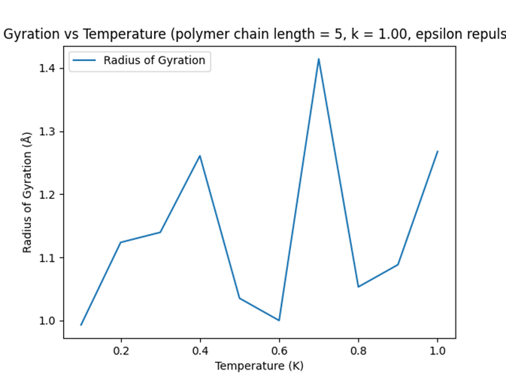

**Figure 11.** Radius of gyration vs temperature (polymer chain length = 5, *k* =1.00, epsilon repulsive = 1.00)

**Figure 12.** Radius of gyration vs temperature (polymer chain length = 10, *k* =1.00, epsilon repulsive = 1.00)

**Figure 13.** Radius of gyration vs temperature (polymer chain length = 40, *k* =1.00, epsilon repulsive = 1.00)

**Figure 14.** Radius of gyration vs temperature (polymer chain length = 100, *k* =1.00, epsilon repulsive = 1.00)

1. **Discussion**

**4.1 Temperature-dependent phase transition**

The simulation results revealed a temperature-dependent folding-unfolding transition of the polymer chain. As shown in Figures 2 to 6, the polymer chain configuration transitioned to an unfolded state as the temperature increased from 0.6 K to 0.7 K. At low temperatures, the radius of gyration remained relatively small and constant, as the attractive interactions between particles dominated, causing the polymer chain to aggregate into a compact folded state. At higher temperatures, the particles gained sufficient kinetic energy to overcome the attractive interactions, leading to an extended configuration.

**4.2 The influence of the simulation parameters**

In this project, various simulation parameters, including the spring constant (*k*), the depth of the repulsive potential (εrepulsive) and the polymer chain length were investigated to study their influence on the folding-unfolding transition.

When a small spring constant *k* was applied to the simulation, the bonded interaction between the particles was weak, mimicking a polymer chain with a flexible structure. The radius of gyration for the polymer chains with small values of *k* were greater than those with a larger *k*, indicating that flexible polymer chains are more likely to adopt an unfolded state. This occurs because flexible chains can rotate and bend into numerous configurations, with entropy driving the polymer chain to form a random coil.

The depth of repulsive potential also has an impact on the folding-unfolding behavior. In general, a large depth of repulsive potential causes particles to maintain greater distances from each other, leading to an unfolded configuration.

Finally, as the simulation results shows, a longer polymer chain favors the unfolded configuration. Because longer polymer chains have more freedom thus more flexible to form different configurations compared to shorter polymer chains. Additionally, the entropy also drives the longer polymer chain to form an unfolded state with more random configurations.

**4.3 Implications for polymer design in space applications**

Based on the simulation results, if we want to design a polymer material that can remain unfolded and maintain their structural integrity at the low temperatures in space environments, we should make a polymer that has a relatively weak bonded interaction and strong repulsive non-bonded interaction between the repeating units. Additionally, the chain length, or molecular weight of the polymer, should be as large as possible.

A potential polymer structure that meets these requirements is shown in Figure 15. This polymer features a flexible polyethylene backbone incorporated with quaternary ammonium groups. The presence of cations within these groups generates a strong repulsive potential between the repeating units, helping to maintain the unfolded configuration.



**Figure 15.** Polymer design for space applications.

1. **Conclusions**

In this project, we investigated the folding-unfolding transition of a polymer chain using molecular dynamics simulations. The results revealed how the folding-unfolding behavior is influenced by temperature, spring constant, and the depth of the repulsive potential, offering valuable insights for the design of polymer materials suited for space applications.

For future studies, researchers could perform energy minimization prior to starting the molecular dynamics simulations to identify a stable initial configuration. This step would enhance the reliability and robustness of the simulation results.

**Reference**

1. Alfred Rudin, Phillip Choi, in The Elements of Polymer Science & Engineering (Third Edition), 2013

**Supporting Information**

The python codes and results of the simulation have been uploaded to GitHub: [yufei1009/comp-prob-solv: Homework for Chem 4050/5050 Computational Problem Solving in the Chemical Sciences](https://github.com/yufei1009/comp-prob-solv)